
Welcome back to the final term in Year 6, the Snow Leopards and Penguin classes, taught by Miss Moore and Mr Nicholls. This is always a term that is packed full of excitement, happiness, a few tears and lots of fun. We have the Year 6 play, the leavers assembly where we remember all the lovely memories, we have all shared. The children will be experiencing two days at their new secondary school and having a taster of what life after primary school will be like. In between all that we will they will still be working hard on their topic – Sports Science.

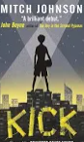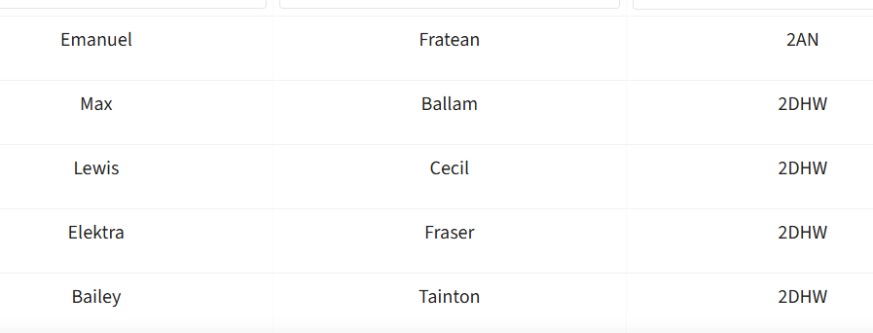
Year 6 Summer 2 Newsletter.
REMINDERS
PE will be on a Thursday for Penguins and Thursday for Snow Leopards (swimming)
Please remember to come to school in your PE kit, including suitable trainers – crocs or sandals are not appropriate.
(Plain T-shirt, plain Joggers or Shorts and school cardigan/jumper).

Don’t forget that some weeks are swimming for PE – this is a compulsory part of the curriculum with pupils working towards swimming a minimum of 25 metres.

Other key information and key dates for your diary:
Year 6 production 16th July at 5.00pm and 17th July at 2.30pm
Year 6 Leavers Party 4.30-6.30pm – 21st July
End of term celebration assembly for Year 6 - 1.30pm 22nd July
Year 6 – colour bomb and water fight 22nd July 2.45 pm

 Y

I In English we will be reading Kick by Mitch Johnson
Kick is about a boy called Budi who lives in Jakarta, Indonesia, and works in a factory making football boots instead of going to school. He dreams of becoming a famous footballer, but after accidentally breaking a dangerous gangster’s window, he is forced into serious trouble. The story explores poverty, friendship, hope, and chasing dreams despite difficult circumstances

The Boy

In Maths, the pupils will be applying all their mathematical knowledge to themed projects and problem solving.
In PSHE, Year 6 will be looking at self-esteem, positive relationships, respecting their bodies and the changes they experience through puberty. They will also explore the development and birth of a baby.

In Geography this term, pupils will be refreshing their knowledge of human and physical knowledge. They will be doing field work to explore the local area and learning map skills.

In Computing this half term, we will be building step counters using the Micro:Bits

In Art, pupils will be practising their sketching and learning techniques to draw the human body.

In Science, we will be learning about animals including humans. How the human body works, dietary needs, nutrition, life cycles of humans and other animals.

In RE, we will be exploring Christianity and reflecting on the pupil’s understanding of Christianity.

In PE, we are building our spatial awareness and team building skills through playing a variety of wide and invasion games on the weeks when pupils are not swimming. Swimming is compulsory for all pupils on the weeks scheduled.

What can you do to support your child’s learning?

- Ask questions about their learning that day - this is vital for embedding their learning and developing recall (daily)
- Times Tables Rockstars (daily)
- Spelling Shed (weekly)
- Read regularly (Record using the Rainbow Reading cards)
- BBC bitesize
- Take an interest in current affairs – watch and discuss the news together

Thank you

Liz Moore and Phil Nicholls
Contacting the year 6 team
We are at the classroom door at drop off and pick up times and we are always happy to say hello or have a quick chat.
Call the office to pass on a message or ask for a call back. 0115 9152953
Don’t forget to download the DOJO app and keep an eye on the website and Facebook page for up-to-date information and key messages.

